Update New certificate of Service Provider (iContracts) on ADFS IdP
Note – iContracts Certificate is same for both Signing and Encryption and MUST be updated on both Signing and Encryption tabs.
- Go to ADFS Management Console.
- Locate the appropriate Relying Party Trust for iContracts (Staging Test or Production when ready to update Production).
- Open its Properties.
- Go to the Signature Tab
  - Remove the old iContracts (SP) Certificate and
  - Browse and Add the new Certificate
  - Apply the new configuration.
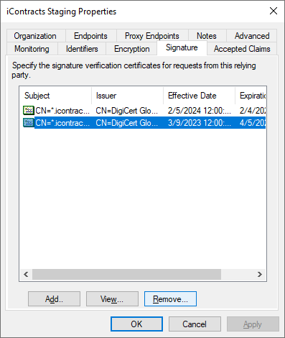
- Then go to the Encryption Tab and Browse and select the new certificate.
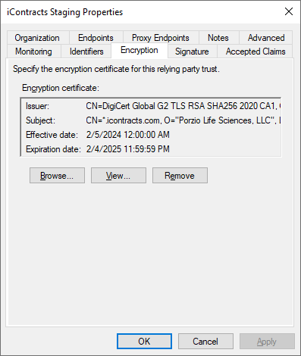
- Save the Configuration.

