Update New certificate of Service Provider (iContracts) on OKTA IdP
Note – Some of the following information and screenshot have been obtained from clients in the past and should be used for reference only.
- On Okta Admin Dashboard where you have set up Trust with iContracts, go to SAML Settings->Show Advanced Settings
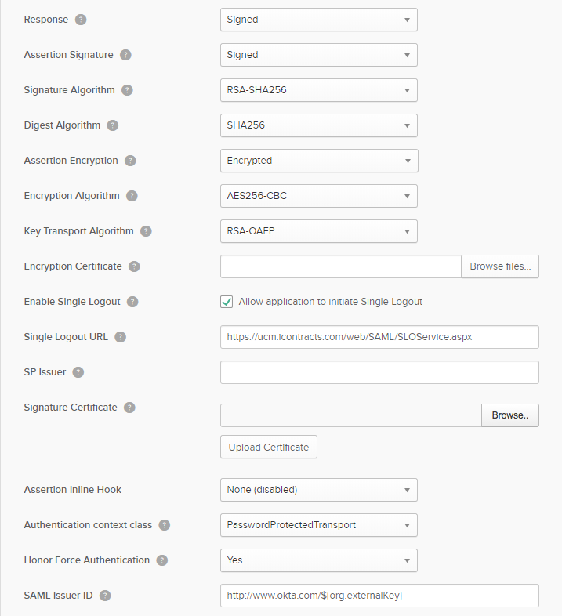

- Find the Signature Certificate file name.
- Click on Browse files...
- Select the new iContracts certificate file to Upload and click Upload Certificate.
- Similarly find the Encryption Certificate file name.
- Click on Browse files...
- Select the new iContracts certificate file to Upload and click Upload Certificate.
Note – iContracts certificate is same for both Signing and Encryption.

