Update New certificate of Service Provider (iContracts) on AZURE IdP
Note – Some of the following information and screenshots have been obtained from different clients in the past and should be used for reference only.

- On the Dashboard where you have set up Trust with iContracts -> Go to Security -> Token encryption.
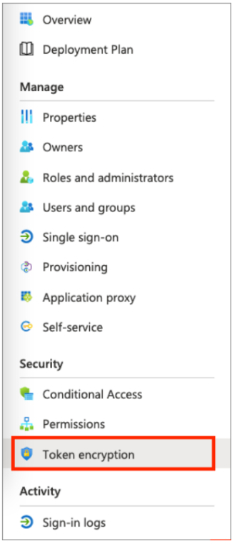

- This is where we are expecting to see the current certificate.
- Find the current certificate and select the ... option next to the thumbprint status to show the dropdown menu. There should be an option to make the current certificate as Inactive by selecting “Deactivate token encryption”.

- Then Import the new certificate that has been provided by the SP (iContracts). Select the ... option next to the thumbprint status and pick “Activate token encryption” to make the new certificate Active. Select Yes to confirm activation of the token encryption certificate.
- Reference screen shot –
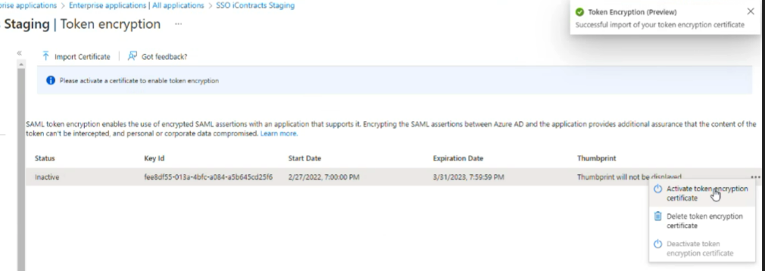
- Reference screenshot after inactivating the old certificate and activating the new one.

